1- Language missing or invalid
e analyzed
Issue analyzed

The language of the document is not identified

Code:

<html lang="Default">

Explanation:

Identifying the language of the page or page elements allows screen readers to read the content in the appropriate language.

It also facilitates automatic translation of content.

Action recommended:

Identify the document language using the <html lang> attribute with a valid value (e.g., <html lang="en">). Ensure that all lang attribute values are valid.

Reference:

https://webaim.org/standards/wcag/checklist#sc3.1.1

3.1.1 Language of Page (Level A)

2- Removing Black Hat (Adding invisible keywords):

Black hat SEO is a practice against search engine guidelines,

used to get a site ranking higher in search results.

These unethical tactics don’t solve for the searcher and often end in a penalty from search engines.

Black hat techniques include keyword stuffing and using private link networks.

Issue analyzed

Adding invisible keywords

Code:
<div class="keywords" style="color: rgb(204, 204, 204); font-size: 1px;">
web agency atlanta, web strategy, web design, logo, website, web, internet, logo design
</div>

Explanation:

Appearing in search results is vital for business growth,

but there’s a right and wrong way of doing search engine optimization.

The dark art of black hat SEO is the wrong way.

Black hat SEO seeks to game search engine algorithms, rather than solve for the user.

Good practice to adopt:

White hat SEO is a more ethical way of doing SEO by creating quality content and a good user experience.

Action recommended:

Write only good quality original content that avoids keyword stuffing. Never scrape, duplicate or reword content that belongs to others.

Reference:

https://blog.hubspot.com/marketing/black-hat-seo

3- Contrast Errors

Issue analyzed

Very low contrast between text and background colors.

Explanation:

Very low contrast between text and background colors. Adequate contrast of text is necessary for all users, especially users with low vision.
Good practice to adopt:

Increase the contrast between the ext color and the background color.

Large text (larger than 18 point or 14 point bold) does not require as much contrast as smaller text.

Action recommended:

Text is present that has a contrast ratio less than 4.5:1,

or large text (larger than 18 point or 14 point bold)

has a contrast ratio less than 3:1.

WCAG requires that page elements has background color that provide sufficient contrast.

Reference:

https://webaim.org/standards/wcag/checklist#sc3.1.1

1.4.3 Contrast (Minimum) (Level AA)

4- Empty link

Issue analyzed

A link contains no text.

Explanation:
If a link contains no text, the function or purpose of the link will not be presented to the user.

This can introduce confusion for keyboard and screen reader users.

Good practice to adopt:

Remove the empty link or provide text within the link that describes the functionality and/or target of that link.
Action recommended:
Remove the empty link or provide text within the link that describes the functionality and/or target of that link.
Reference:

https://webaim.org/standards/wcag/checklist#sc3.1.1

2.4.4 Link Purpose (In Context) (Level A)

5- Missing form label

Issue analyzed
Missing form label
Code:
For example:

<label>
Name
</label>
<input id="name"class="form-control"required="">
</div>
Explanation:

A form control does not have a corresponding label.

Good practice to adopt:
If a form control does not have a properly text label,

the function or purpose of that form control may not be presented to screen reader users.

Form labels also provide visible descriptions.

Action recommended:

- a <label> element with a for attribute value that is equal to the id of a unique form control
Reference:

https://webaim.org/standards/wcag/checklist#sc3.1.1

1.1.1 Non-text Content (Level A)
1.3.1 Info and Relationships (Level A)
2.4.6 Headings and Labels (Level AA)
3.3.2 Labels or Instructions (Level A)
6- Document does not have a meta keywords(SEO)

Issue analyzed

Document does not have a meta keywords
Keywords text is empty in page 2.
Code:

<meta name="keywords" content="">

Explanation:

SEO keywords are terms added to online content in order to improve search engine rankings.

When you optimize your content around words and phrases that people search for, your website can rank higher for those terms.

Good practice to adopt:

Use a unique Keywords for each page and focusing on long tail keywords.
Action recommended:
Use Google Suggest
Long tail keywords are long (usually 4+ word) terms that searchers use in Google and other search engines.

And they tend to have a lower keyword difficulty compared to 1-3 word “head terms”.

Reference:

https://backlinko.com/hub/seo/seo-keywords
https://backlinko.com/keyword-research-tools

7- Document does not have a meta description (SEO)

Issue analyzed

Document does not have a meta description
Description text is empty in page 2.

Code:

<meta name="description" content="">

Explanation:

The<meta name="description">element provides a summary of a page's content

that search engines include in search results.

A high-quality, unique meta description makes your page appear more relevant and can increase your search traffic.

Good practice to adopt:

Use a unique description for each page.
Action recommended:

- Make descriptions clear.
- Avoid vague descriptions.
- Avoid keyword stuffing. It doesn't help users, and search engines may mark the page as spam.

Reference:

https://web.dev/meta-description/?utm_source=lighthouse&utm_medium=devtools

8- Document does not have a meta title tag(SEO)

Issue analyzed

Document does not have a title.
Title tag is empty. (.)

Code:

<title>.</title>

Explanation:

A title tag is an HTML tag.

That labels your page for both real people and search engines.

They also appear at the tops of browser tabs.

Just like the title of a book catches users attention,

a page’s meta title tag is the first step that invites people to click on your page in search engine.

Google’s algorithm recognizes the title as a major sign of the page’s purpose and relevance.

Good practice to adopt:

Look for unique, detailed title tags for each page on your site

Action recommended:

Create an original title
Consider the keywords you’re targeting and what makes your business unique.

2- Insert the central keywords

It’s crucial to place your foundational keywords into your SEO title tag
Reference:

https://www.webfx.com/blog/seo/title-tag/

9- Image elements do not have a good [alt]attributes.

Issue analyzed
Image elements do not have a good alt attributes

Good practice to adopt:

Alt text should give the meaning of the image.

Blind users should get as much information from alt text as a sighted user gets from the image.

Avoid non-specific words like "chart", "image", or "diagram"

Action recommended:

Provide an alt attribute for every<img> element.
If the image fails to load, the alt text is used as a placeholder so users have a sense of what the image was trying to convey.
Reference:

https://web.dev/image-alt/?utm_source=lighthouse&utm_medium=devtools

10- script tag in the head section of a page

Issue analyzed

script tag in the head section of a page

Which will decrease page Load Performance.

Explanation:

When you think of improving page load performance, you try to optimize the back-end code, database connections, and so on.

One of the easiest ways to improve the page load speeds is by making some small adjustments to how you load the JavaScript.

Render flow when the script tag is in the head section of the page

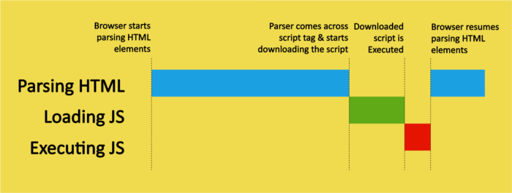

Good practice to adopt:

Add defer Attribute Within the script Tag

Action recommended:

When the parser comes across a script tag with a defer attribute,
This attribute executes the scripts after all the HTML parsing is complete before the document ready event is triggered.
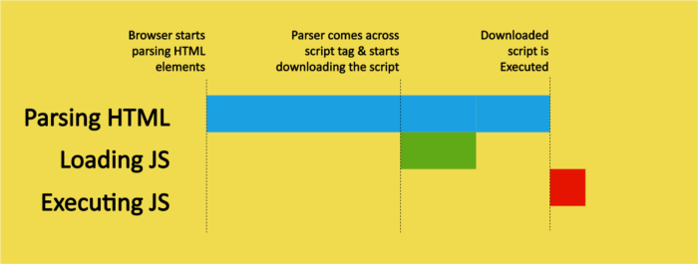

Reference:

https://betterprogramming.pub/improve-page-load-performance-with-these-different-script-loading-techniques-b0d912eae7b1

11- Image optimization

Issue analyzed

Large, under-optimized images slow down site speed and
drive people away from your website.

Good practice to adopt:

- Large images slow down your web pages which creates a less than optimal user experience. Optimizing images is the process of decreasing their file size.

Action recommended:

The goal of image optimization is to create high-quality images with the lowest file size.
Compress images to reduce file size
Reference:
https://getflywheel.com/layout/optimize-images-for-web/

